- This is a bug. These pages are missing data. The pages are blank. Comment: Done
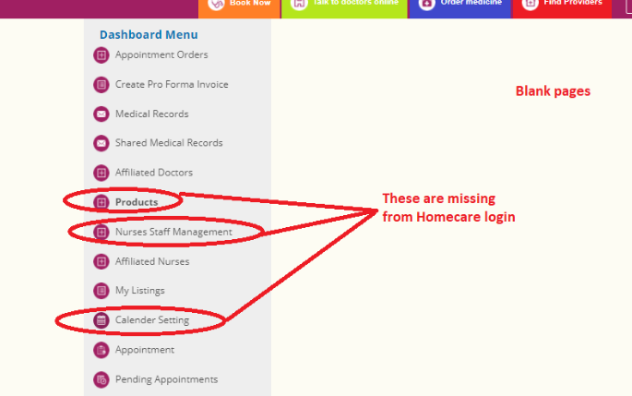

- Please translate. This is missing Comment: Done
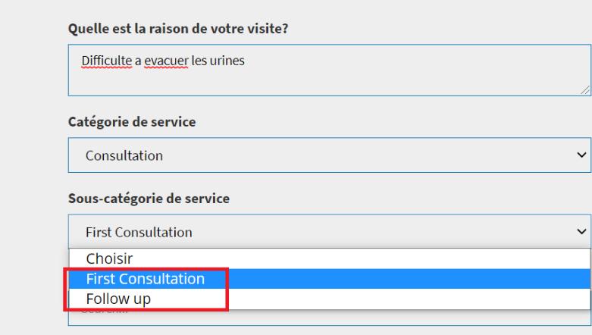

- Font is too big for mobile please reduce font to 10 points. Comment: Done
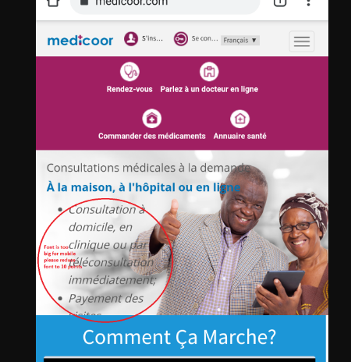

- Fix font under appointment Comment: Done 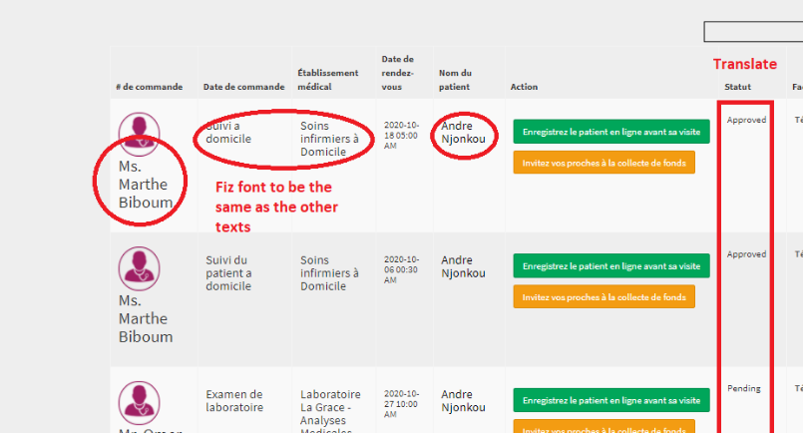

- Translation missing under pharmacie Comment: Done

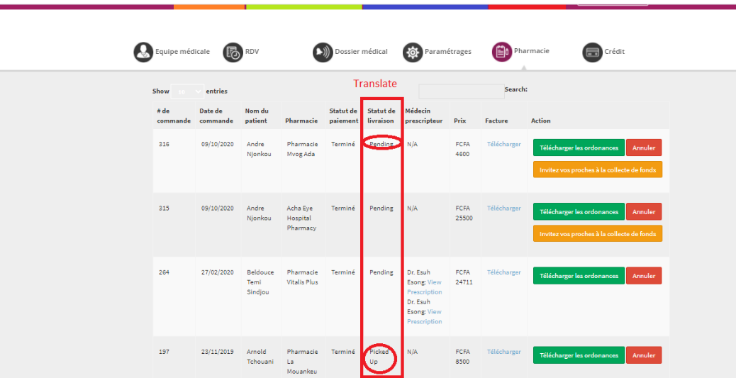

- Translation missing under client setup tab Comment: Done
